**SMART WATER IRRIGATION SYSTEM**

**USING ARDUINO UNO**

A Mini Project Report Submitted

 By

**SHAIK ZEBA BATOOL (1604-19-737-019)**

**MADIHA SIDDIQUE (1604-19-737-014)**

**NOHA ABDUL RAFE (1604-19-737-006)**

**INFORMATION TECHNOLOGY DEPARTMENT**

**MUFFAKHAM JAH COLLEGE OF ENGINEERING & TECHNOLOGY**

**(Affiliated to Osmania University)**

Banjara Hills, Hyderabad - 500034

**2021-2022**

**MUFFAKHAM JAH COLLEGE OF ENGINEERING & TECHNOLOGY**

**(Affiliated to Osmania University)**

Banjara Hills, Hyderabad - 500034

**DEPARTMENT OF INFORMATION TECHNOLOGY**



**CERTIFICATE**

It is certified that the work contained in the project report titled **“SMART WATER IRRIGATION SYSTEM USING ARDUINO UNO”** by

**SHAIK ZEBA BATOOL (1604-19-737-019)**

**MADIHA SIDDIQUE (1604-19-737-014)**

**NOHA ABDUL RAFE (1604-19-737-006)**

has been carried out under my/our supervision and that this work has not been submitted elsewhere for a degree.

Project Supervisor Signature of Head

**Dr.SYEDA FOUZIA SAYEEDUNNISA Dr.MOUSMI AJAY CHAURASIA**

Information Technology Dept. Information Technology Dept.

MJ College of Engineering & Tech. MJ College of Engineering & Tech.

Hyderabad – 500034. Hyderabad – 500034

**External Examiner**

**DECLARATION**

We, **Shaik Zeba Batool, Madiha Siddique, Noha Abdul Rafe** bearing Roll No. **1604-19-737-019, 1604-19-737-014, 1604-19-737-006** respectively.Here by declare that the project report entitled **“SMART WATER IRRIGATION SYSTEM USING ARDUINO UNO**” is done as mini project during the Course work of VI Sem BE(IT) and is done under the guidance of Dr. S. Fouzia Sayeedunnisa, Associate Professor, Department of Information Technology, Muffakham Jah College of Engineering and Technology.

This is a record of bonafide work carried out by us in Muffakham Jah College of Engineering & Technology and the results embodied in this project have not been reproduced or copied from any source.

**By**

**SHAIK ZEBA BATOOL (1604-19-737-019)**

**MADIHA SIDDIQUE (1604-19-737-014)**

**NOHA ABDUL RAFE (1604-19-737-006)**

**Department of Information Technology,**

**Muffakham Jah College of Engineering and Technology,** **Banjara Hills, Hyderabad - 500034.**

**ACKNOWLEDGEMENT**

We would like to take the opportunity to express our sincere thanks to our mini project coordinator Dr. S.Fouzia Sayeedunnisa, Associate Professor, Information Technology, MJ College of Engineering & Technology, for her invaluable support and guidance throughout our project work. Without her kind guidance & support this was not possible. We are grateful to her for her timely feedback which helped us track and schedule the process effectively. Her time, ideas and encouragement that she gave helped us complete our project efficiently.

We would also like to thank Dr.Mousmi Ajay Chaurasia, Head of Information Technology Department, for her encouragement and for providing an outstanding academic environment, also for providing the adequate facilities resources.

We sincerely acknowledge and thank Mr. T. Nooruddin, Lab Technician, MJ College of Engineering & Technology who provided timely guidance in the completion of this project work.

**ABSTRACT**

Due to various day-to-day activities human life is busy and it is hard to keep track of scheduled watering of plants. And outdoor water uses alone averages more than 9 billion gallons of water each day mainly for landscape irrigation. As much as 50% of this water is wasted due to overwatering caused by inefficiencies in traditional irrigation methods and systems. Smart irrigation technology is the answer.

Unlike traditional irrigation controllers that operate on a pre-set programmed schedule, smart irrigation controllers monitor whether, soil conditions, evaporation, and plant water use to automatically adjust the watering schedule to actual conditions on the site.

The project is meant to demonstrate smart water irrigation using soil moisture sensor controllers. The components used are Arduino Uno, 5V relay, jumper wires, water pump, soil moisture sensor module and motor for water pump. This sensor when buried in the root zone of turf, trees or shrubs it accurately determines the moisture level in the soil and transmit this reading to the controller. If the moisture is low, it signals the relay, and the pump will be turned on. If moisture goes up to 55% and after that pump will be turned off.

**LIST OF FIGURES**

|  |  |  |
| --- | --- | --- |
| **Figure number** | **Figure Name** | **Page number** |
| 1. | Arduino uno component structure | 10 |
| 2. | Soil moisture sensor component structure | 11 |
| 3. | Relay board component structure | 12 |
| 4. | DC motor pump component structure | 12 |
| 5. | Block diagram of Irrigation system | 17 |
| 6. | Flow chart of Irrigation system | 17 |
| 7. | Circuit diagram of Irrigation system | 18 |
| 8. | Code of Arduino Uno IDE | 21 |
| 9. | Output Screenshot of Irrigation system | 21 |

**INDEX**

**CONTENTS Page No.**

1. **INTRODUCTION 7 - 8**
   1. **PROBLEM STATEMENT**
   2. **SCOPE AND OBJECTIVE**
2. **LITERATURE SURVEY 9 - 12**

**2.1 RELATED RESEARCH PAPERS**

**2.2 HARDWARE SPECIFICATIONS**

**2.2.1 ARDUINO UNO**

**2.2.2 SOIL MOISTURE SENSOR**

**2.2.3 RELAY BOARD**

* + 1. **DC MOTOR PUMP**

**3. SYSTEM ANALYSIS 13 - 16**

**3.1 PROBLEMS WITH EXISTING SOLUTION**

**3.2 PROPOSED SYSTEM**

**3.2.1 PROCEDURE/WORKING**

* 1. **ADVANTAGES OF PROPOSED SYSTEM**

**4. SYSTEM DESIGN 17 - 19**

**4.1 BLOCK DIAGRAM**

**4.2 FLOW CHART**

**4.3 CIRCUIT DIAGRAM**

* 1. **APPLICATIONS OF IRRIGATION SYSTEM**

**5. IMPLEMENTATION 20 - 21**

**5.1 MODULE DESCRIPTION**

**5.2 CODE**

**5.3 OUTPPUT SCREENSHOT**

**6. CONCLUSION 22**

**7. FUTURE ENHANCEMENTS 23**

**8. REFERENCES 24**

1. **INTRODUCTION**

Internet of Things is a network of computing devices which can collect and exchange the data. Due to day-to-day activities human life is busy and it is hard to keep track of scheduled watering of plants. Therefore, water controlling system implementation makes potential significance in home appliances. Arduino is an open-source electronics electronic platform based on easy-to-use and software. Arduino boards can read inputs and turn it into an output like activating a motor. Over the years Arduino has been the brain thousands of projects, from everyday objects to complex scientific instruments.

Unlike traditional irrigation controllers that operate on a pre-set programmed schedule, smart irrigation controllers monitor whether, soil conditions, evaporation, and plant water use to automatically adjust the watering schedule to actual conditions on the site.

Using Arduino and Internet of Things, irrigation of home garden can be automated. The Smart Water Irrigation system uses a sensor that checks the moisture level in the soil and automatically turns the water pump on till the moisture level in the soil reaches up to a particular level.

**1.1 PROBLEM STATEMENT**

Nowadays, despite being an agricultural country, the number of people who die of hunger is still quite high. Access to food seems to be difficult, as price and quantity of food is still beyond the capability of the lower middle class and lower class. Irrigation induced Crop failure is a major cause of crop loss every year, and in the age of water crises, this has been elevated to great levels. In order to keep up with increasing demand, farmers are required to increase crop efficiency, by rapidly advancing technologies. In order to handle Irrigation issues, this system has been devised and implemented. Usually, farmers need large scale manpower to irrigate large lands simultaneously. However Smart Water Irrigation System (SWIS) is an automatic system that facilitates automated irrigation of lands simultaneously, upon need. Smart irrigation system is a method that prevent of wasting water in small scale such as home garden or even in big scale like football or agriculture field.

* 1. **SCOPE AND OBJECTIVE**

The motivation for this project came from the countries where economy is based on agriculture and the climatic conditions lead to lack of rains & scarcity of water. Our country mostly depends on agriculture. The farmers working in the farmlands are solely dependent on the rains and bore wells for irrigation of the land. Even if the farmland has a water-pump, manual intervention by farmers is required to turn the pump on/off whenever needed. In the same way, home gardens also need irrigation which need not be done manually each time.

The objective of this hardware is to provide automation of irrigation to lessen the responsibility of the owner to particularly take care of their gardens.

1. **LITERATURE SURVEY**

**2.1 RELATED RESEARCH PAPERS**

Kaushik Gupta, Mandar Kulkarni, Manas Magdum, Yash Baldawa and Prof. Shivprasad Patil proposed Smart Water Management in Housing Societies using IoT to provide solution for water management for houses. But this system was fully automated by not providing user interaction. Shavarsidha Gunde, Dr. V. P.Baligar, Prof. A. K. Chikaraddi proposed IoT Based Flow Control System using Raspberry PIto monitor water level in overhead tank. A web application was developed which did not provide user interaction. Priyen P. Shah, Anjali A. Patil, Subodh S. Ingleshwar proposed IoT based Smart Water Tank with Android application for monitoring and controlling the tank. System uses ultrasonic sensors which are less efficient. Cristina Turcu, Cornel Turcu, Vasile Gaitan proposed An Internet of Things Oriented Approach for Water Utility Monitoring and Control for measuring and displaying water content. The system is more time consuming and consumes more power. Thinagaran Perumal, Md Nasir Sulaiman, Leong.C.Y proposed. Internet of Things (IoT) Enabled Water Monitoring System to monitor water level in tank. System uses ultrasonic sensors which may also provide inaccurate results. Sayali Wadekar, Vinayak Vakare, Shivam Yadav proposed Smart Water Management Using IOT to manage and plan water usage. System notifies current water level in tank, but user has to manual operate the motor. Amrit Kumar Panigrahi1, Chandan Kumar Singh, Diwesh Kumar, Nemisha Hota proposed Tank Water Level Indicator & Controller Using Arduino for displaying water level. But a seven-segment decoder is used to display level of water. It is more time consuming.

* 1. **HARDWARE SPECIFICATIONS**

**2.2.1 ARDUINO UNO**

The Arduino Uno is a microcontroller which is based on the ATmega328 datasheet. It has 14 digital input/output pins. It is an open-source microcontroller which is used to control relay, simply connect to a computer with a USB cable or power it with an AC-to-DC adapter or battery to get started. It is a large assortment of included libraries for interfacing to wide range of hardware. The UNO differs from all preceding boards in that it does not use the FTDI USB-to-serial driver chip.

**Component Structure:**

1. Arduino Uno component structure

* + 1. **SOIL MOISTURE SENSOR AND PROBE**

Soil moisture sensors measure the volumetric water content in soil. Since the direct gravimetric measurement of free-soil moisture requires removing, drying, and weighting of a sample, soil moisture sensors measure the volumetric water content indirectly by using some other property of the soil, such as electrical resistance, dielectric constant, or interaction with neutrons, as a proxy for the moisture content. The relation between the measured property and soil moisture must be calibrated and may vary depending on environmental factors such as soil type, temperature, or electric conductivity. Reflected microwave radiation is affected by the soil moisture and is used for remote sensing in hydrology and agriculture. Portable probe instruments can be used by farmers or gardeners.

**Component Structure:**

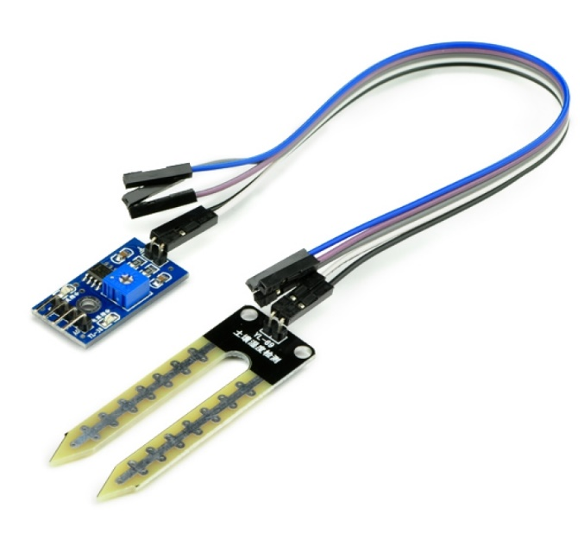

2.Soil moisture sensor component structure

* + 1. **RELAY BOARD**

A relay is an electrically operated switch. Many relays use an electromagnet to mechanically operate a switch, but other operating principles are also used, such as solid-state relays. Relays are used where it is necessary to control a circuit by a separate low power signal, or where several circuits must be controlled by one signal. The first relays were used in long distance telegraph circuits as amplifiers: they repeated the signal coming in from one circuit and re-transmitted it on another circuit. Relays were used extensively in telephone exchanges and early computers to perform logical operations. Electromagnetic relays are those relays which are operated by electromagnetic action. Modern electrical protection relays are mainly micro-processor based, but still electromagnetic relay holds its place. It will take much longer time to be replaced all electromagnetic relays by micro-processor based static relays.

**Component Structure:**

3. Relay board component structure

* + 1. **DC MOTOR PUMP**

A DC motor is any of a class of rotary electrical machines that converts direct current electrical power into mechanical power. The most common types rely on the forces produced by magnetic fields. Nearly all types of DC motors have some internal mechanism, either electromechanical or electronic, to periodically change the direction of current flow in part of the motor. DC motors were the first type widely used, since they could be powered from existing direct current lighting power distribution systems. A DC motor's speed can be controlled over a wide range, using either a variable supply voltage or by changing the strength of current in its field windings. A DC motor pump is essentially a DC Motor that is used to circulate water. The internal structure is the same. The DC motor is encased in a waterproof plastic casing and the shaft is used to drive an external arm that pumps water. The Pump requires a 5V supply, which can be easily provided by batteries or AC supply.

**Component Structure:**

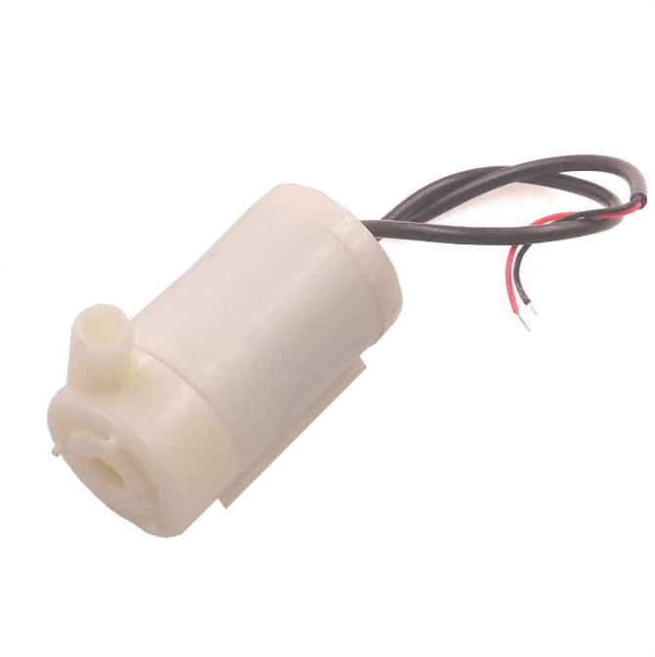

4. DC motor pump component structure

1. **SYSTEM ANALYSIS**

**3.1 PROBLEMS WITH EXISTING SYSTEM**

According to the agricultural view, the continuous extraction of water from earth is reducing the water level due to which lot of land is coming slowly in the zones of un-irrigated land. The existing system of manual irrigation is very inefficient about solving these issues. In modern drip irrigation systems, the most significant advantage is that water is supplied near the root zone of the plants drip by drip due to which a large quantity of water is saved. At the present era, the farmers have been using irrigation techniques in India through manual control in which farmers irrigate the land at the regular intervals.

This process sometimes consumes more water or sometimes the water reaches late due to which crops get dried. Water deficiency can be detrimental to plants before visible wilting occurs. Slowed growth rate, lighter weight fruit follows slight water deficiency. For people who are interested to have fresh fruits and vegetable right in their backyard, but don’t get enough time to water the garden may not want to purchase agricultural irrigation systems like drip irrigation as it will cost more and is not much useful for home gardens.

This problem can be perfectly rectified if we use automatic irrigation system in which the irrigation will take place only when there will be acute requirement of water. And it is affordable for automation of watering plants in home gardens.

**3.2 PROPOSED SYSTEM**

All the lands to be irrigated manually are automatically irrigated by this system. When compared to the previous system where farmers need to frequently and constantly keep monitoring the field for signs of dryness, this system will reduce the time needed to be spent on monitoring the field. It greatly diminishes the need for manpower by a great value. This system will be able to function even when the owner is unavailable for a small period, hence ensuring proper irrigation even in the absence of people. Also, water will not be wasted during traversal.

In recent times, the farmers have been using irrigation technique through the manual control in which the farmers irrigate the land at regular intervals by turning the water-pump on/off when required. This process sometimes consumes more water and sometimes the water supply to the land is delayed due to which the crops dry out. Water deficiency deteriorates plants growth before visible wilting occurs. In addition to this slowed growth rate, lighter weight fruit follows water deficiency. This problem can be perfectly rectified if we use Automated Irrigation System in which the irrigation will take place only when there will be intense requirement of water, as suggested by the moisture in the soil.

Also, smart home technology and home automation have revolutionized life inside the home. But it doesn't end there. Smart gardens are a logical extension of smart homes, using technology to work harmoniously with nature. Irrigating via smart system is more effective and efficient compare with the traditional ones. This system automatically will recognize, irrigate and dung any area that needs water and humidity. while the traditional system just works based on the given program and maybe some region will be overwatered as other parts will keep dry. This offers the opportunity to make the smart garden a functional extension of the smart home, not only saving homeowners money, but offering the reassurance that your garden will be well cared for even when you’re away.

* + 1. **PROCEDURE/WORKING**

The system was tested for black and red soil under the dry and wet conditions. Using these results, a maximum value for the dryness of the soil is set that is 1023 and minimum value is 300. Maximum value is taken as 1023 since the soil moisture sensor can measure value up to this.

So, if the measured value by the sensor is between 1023 to 300 the motor will turn on automatically and initiates supply of water to the crops. However, if the measured value is less than 300 it implies that the soil is wet and hence the motor remains off and no water is supplied to the crops. This project consists of two sections: the external sensor unit, and the inbuilt processing unit.

In the external sensor unit, the basic requirement of sensing the moistness of the sand or soil through capacitive reactance is performed, the arms of the sensor can detect resistance and provide input to the IC. When the soil becomes dry, it produces large voltage drop due to high resistance, and this is sensed by the soil moisture sensor, and this resistance causes the operational amplifier to produce an output that is above the threshold value required. This causes the relay to change from normally open to closed condition – The relay becomes on. When the relay is turned on, the valve opens and water through the pipe’s rushes to the crops.

When the water content in the soil increases, the soil resistance gets decreases and the transmission of the probes gets starts to make the operational amplifier stop the triggering of the relay. Finally, the valve which is connected to the relay is stopped. Op-amp is configured here as a comparator. The comparator monitors the sensors and when sensors sense the dry condition then the project will switch on the motor, and it will switch off the motor when the sensors are in wet. The comparator does the above job it receives the signals from the sensors.

A transistor is used to drive the relay during the soil wet condition. 9V double pole – double through relay is used to control the water pump. LED indication is provided for visual identification of the relay / load status. A switching diode is connected across the relay to neutralize the reverse EMF. This project works with 9V regulated power supply for the internal blocks and uses regulated 12V power supply for the relay board. Power on LED is connected for visual identification of power status.

First, the sensor probes are inserted in the soil at specific locations in the field, at a depth of 5cm from the soil surface at regular intervals in the field. The Arduino Uno is a link between the soil moisture sensor and pumping motor. Arduino is supplied with a power of 7V to 12V.

The pump motor is given a separate supply of 9V. The soil moisture sensor is used in this project because it must check soil moisture to measure the electrical conductivity of soil. The moisture sensor provides an analogue output which can be easily interfaced with Arduino.

In this project two sensors are connected to analogue pins A0 and A1 of the Arduino board. The system receives a signal from the soil moisture sensor and compares with the preset threshold value. If the value detected by the sensor is below the threshold value, the Arduino sends a message signal to the motor to fetch water. But when the value detected by the sensor is above the pre-set value, the motor doesn’t rotate. The Arduino always accepts the signal from the sensor and keeps updating.

* 1. **ADVANTAGES OF PROPOSED SYSTEM**

The main advantage of this project is that it has faster execution when compared to manual execution of the process.

* It is simple, portable and provides high performance.
* It consumes less power Dryness can be easily detected in soil.
* Permits a non- expert to do the work of an expert.
* Improves productivity by increasing work output and improving efficiency.
* Saves time in accomplishing specific objective.
* The smart irrigation system will help to have better control of landscape and irrigation needs as well as peace of mind that the smart system can make decisions independently if the owner is away.
* This will save a significant amount of money on your water bills because through intelligent control and automation, the smart irrigation system will optimize resources so that everything gets what it needs without needless waste.
* This system saves labor cost and water up to 70%. The working of this irrigation system covers over 40 crops spanning across 500 acres.
* Studies show that up to 50% of water usage for landscape irrigation can be saved with cloud-based Smart Irrigation systems.

1. **SYSTEM DESIGN**

**4.1 BLOCK DIAGRAM**

5.Block diagram of the irrigation system

**4.2 FLOW CHART**

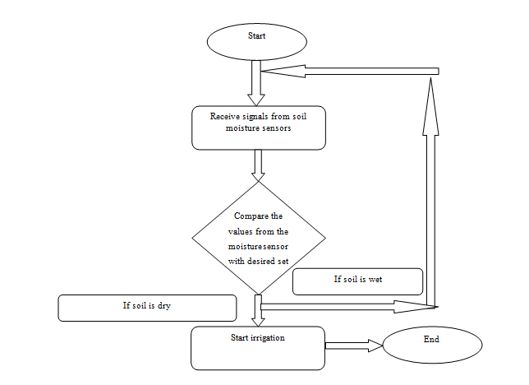

6. Flowchart of working of the irrigation system.

* 1. **CIRCUIT DIAGRAM**

7.Circuit diagram of the project.

* 1. **APPLICATION OF SMART WATER IRRIGATION**
* We propose an application to detect water deficiency state in soil based exclusively on sensor-provided data.
* In an Automated Irrigation System, the most significant advantage is that water is supplied only when the moisture in soil goes below a pre-set threshold value.
* This system can be used in roof gardens in highly populated areas where land is expensive and gardening on rooftops seems like the only viable option left.
* The lawns of houses and public buildings can be maintained by these systems, thereby reducing the need for human monitoring.
* The potential for savings through smart irrigation is even more significant for business and institutions such as schools that manage sports fields and large gardens requiring extensive irrigation.
* The greatest application is in agricultural lands, where farmers are assisted greatly by this. There is no need for the farmer to be present during operation.
* Irrigation in parks needs to be done even when people are not there to maintain the grass or trees.
* Detection in this manner is cheap, non - invasive and can be applied on a population - wide scale.
* Moreover, in dry areas where there is inadequate rainfall, the system can efficiently manage water and ensure better yield of crops by precisely watering.
* The presence of technology in all aspects of life has enabled solutions to real life problem that were either difficult or unfeasible.
  1. **LIMITATIONS OF SMART WATER IRRIGATION**
* The system requires two different power supplies. While implementing in large fields, industrial supply can be used to run the motor. In small gardens this may seem like a large wastage.
* Needs a large amount of sensing equipment for very large irrigation areas.
* The system is not 100% reliable. Unexpected factors can cause errors, and it may in some cases cause loss. Despite being good, it needs to be manually checked and maintained once every few weeks.
* Also, portions of the lawn will have to be dug up to install pipework and attach it to the plumbing system of the home. This can equate to days or weeks without use of the yard.

1. **IMPLEMENTATION**.

Implementation of the project required the design of the system developed in the design phase of the project to be carefully implemented. The extensive implementation of automated systems in agriculture has proven to successfully reduce cost.

* 1. **MODULE DESCRIPTION**

The operation of automated agricultural system could potentially revolutionize the irrigation process and the way it has impacted the commercial & industrial sectors. Thus, this project has been an expert or non-expert-system-based method of field monitoring for detecting dryness & treatment of the field.

The prototype system food and beverage industry have the potential to be useful for the industry, seeking ways to make agriculture cost effective. Furthermore, the ultimate beneficiaries of the project are the farmers who are the backbone of an agricultural economy. The Objective of the project planning is to provide a framework that enables an owner to make reasonable estimate of the resources, cost and schedule.

The project leader is responsible for designing the system precisely according to the requirement specified by the owner/customer. He is also responsible for maintenance of the system for certain period, since in most cases, cost of maintenance is much higher than cost of developing the system. Thus, to reduce development and maintenance cost and to provide the system within planned time, proper planning of system is necessary.

The most crucial phase of managing system projects is planning to launch a system investigation, we need a master plan detailing the steps to be taken, the people to be questioned, and outcome expected. The initial investigation has the objective of determining whether the user’s request has potential merits the major steps are defining user requirements, studying the present system and defining the performance expected by candidate system to meet user requirements.

The first step in the system development life cycle is the identification of need. There may be a user request to change, improve or enhance an existing system. The initial investigation is one way of handling these needs. The objective is to determine whether the request is valid and feasible before a recommendation is reached to do nothing, improve or modify the existing system, are to build a new one. Thus, for an effective test and written paper follow-up data resulting from different circumstances, it is vital to design the APIS.

* 1. **CODE**

8.Code of Arduino program.

* 1. **OUTPUT SCREENSHOT**

9.Setup of the irrigation system.

1. **CONCLUSION**

Irrigation becomes easy, accurate and practical with the idea above shared and can output from moisture sensor and level system plays major role in producing the output. Thus the “**SMART WATER IRRIGATION SYSTEM**” (SWIS) has been designed and tested successfully.

It has been developed by integrating all the features of all the hardware components used. Presence of every module has been reasoned above and placed carefully in order to contribute to the best working of the unit.

The system has been tested to function automatically, and to the best of its ability. The moisture sensors measure the moisture level (water content) of the different plants. If the moisture level is found to be below the desired level, the moisture sensor sends the signal to the operational amplifier which triggers the DC Motor pump to turn ON and supply the water to respective field area.

When the desired moisture level is reached, the system halts on its own and the DC Motor pump is turned OFF. Thus, the functionality of the entire system has been tested thoroughly and it is said to function successfully.

The Arduino based automatic smart irrigation system is simple and precise way of irrigation. Hence, this system is very useful as it reduces manual work of the farmers and helps in the proper utilization of resources. It eliminates the manual switching mechanism used by the farmers to ON/OFF the irrigation system.

This project can be extended to greenhouses where manual supervision is less. Fully automated gardens and farmlands can be created using this principle in the right manner on large scale.

1. **FUTURE ENHANCEMENTS**

The application certainly is much more advantageous than the manual system. There will be no bias in the regions being covered and the delay is kept as minimal as it can be.

* The operator does not require any previous training because of its user friendliness.
* The operator is free from any technical issues.
* Extremely simple design makes the circuit easy to implement and maintain.
* Alterations in the system can be done easily if the process of the working changes in future.
* In future according to the user’s requirement it can be updated to meet the user requirements.
* Smart Wi-Fi Irrigation Controllers are next generation controllers that adjust your irrigation system automatically using real-time weather information. Moreover, you can control it from anywhere, anytime.
* It can help to learn how various sensors can be deployed and utilization of their data to generate events and control irrigation systems.

1. **REFERENCES**

* <https://www.researchgate.net/publication/359107497_SMART_IRRIGATION_SYSTEM>
* <https://www.academia.edu/39700687/SMART_WATER_MANAGEMENT_SYSTEM>
* <https://extension.okstate.edu/fact-sheets/smart-irrigation-technology-controllers-and-sensors.html>
* <https://www.ncbi.nlm.nih.gov/pmc/articles/PMC7070544/>
* <http://ageconsearch.umn.edu/bitstream/27974/1/02010009.pdf>